941-23 guruh talabasi Shonazarov Anvarbekning Mobil ilovalarni ishlab chiqish fanidan bajargan 7-amaliyot ishi

Mobil ilovalarda ma'lumotlar bazasi, REST API va foydalanuvchi interfeysi bilan ishlash (CRUD amallari va OOP asosida)

Loyiha haqida
Anvar Bog'cha CRM loyihasida ma'lumotlar Django backend bazasida saqlanadi, mobil ilova esa REST API orqali ushbu ma'lumotlarni oladi va yangilaydi.
Tarbiyachi roli uchun mobil ilovada token autentifikatsiya, dashboard, davomatni belgilash va vasiylar kontaktlarini ko'rish funksiyalari mavjud.
1-rasm. iOS simulatorda tarbiyachi login oynasi
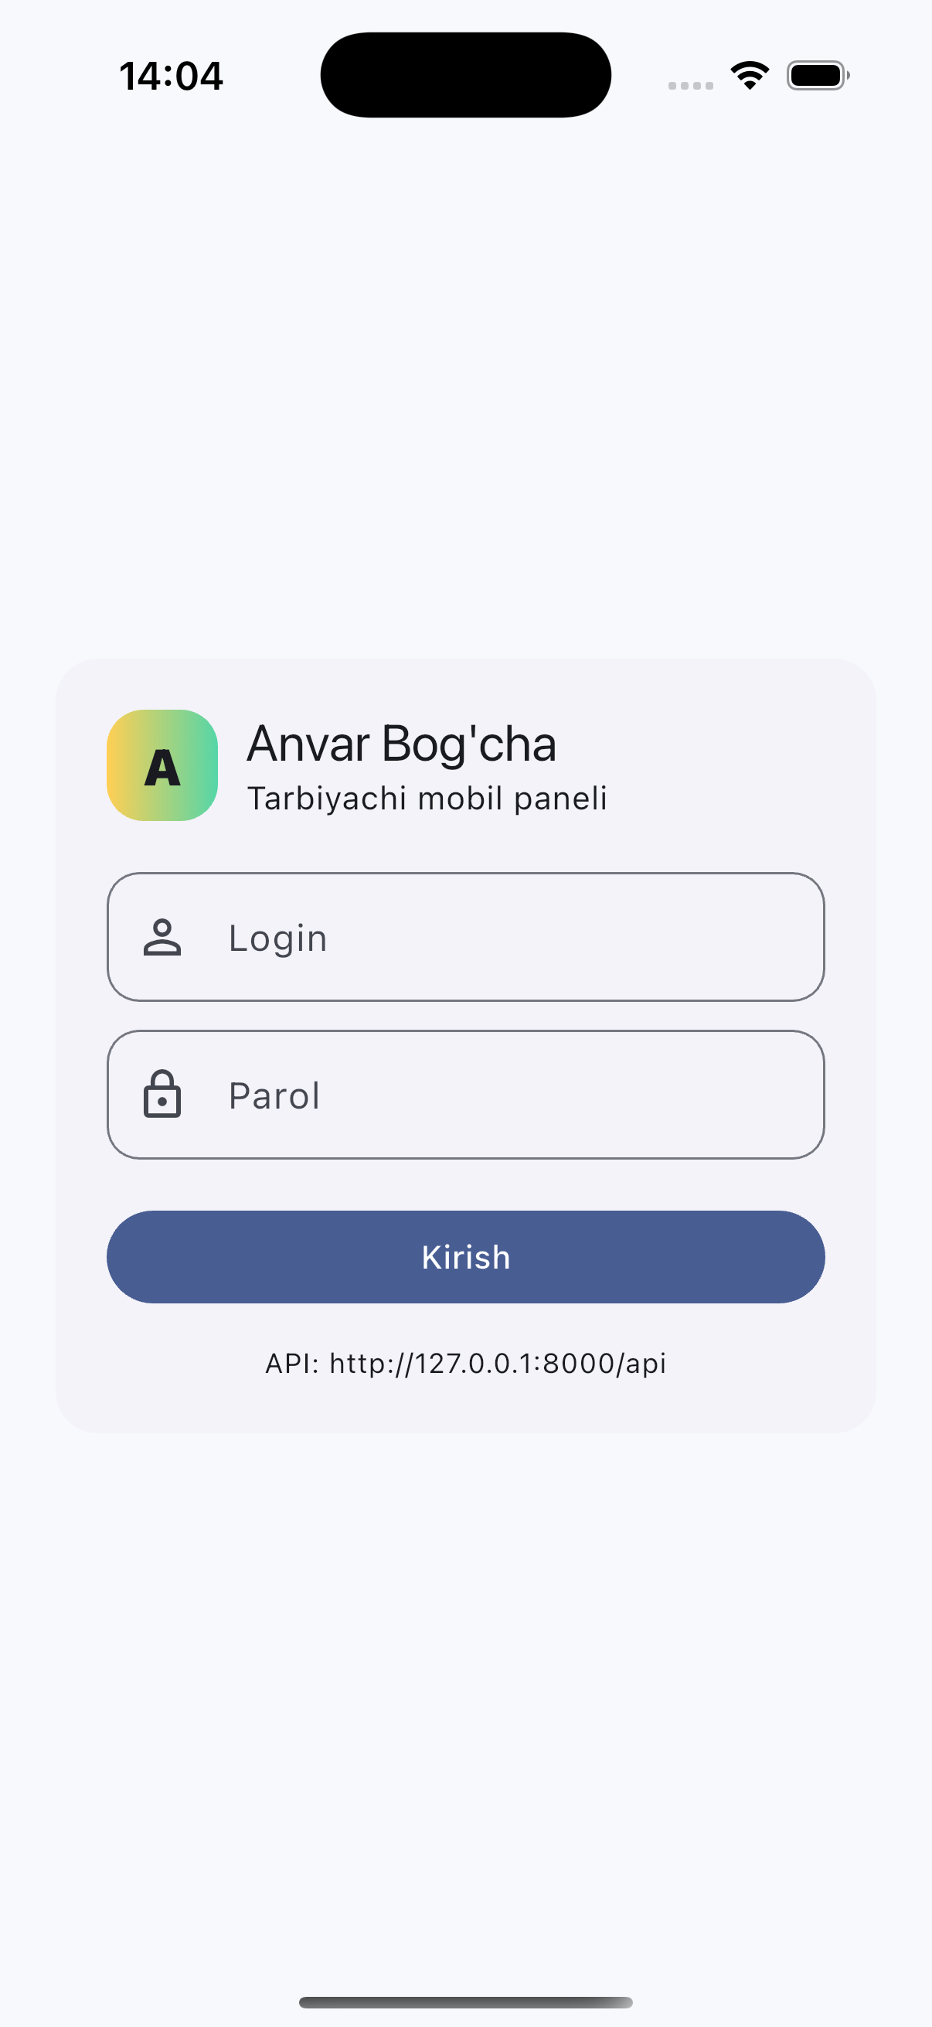

Token autentifikatsiya
Mobil ilova serverga login va parol yuboradi. Backend foydalanuvchi rolini tekshiradi va faqat educator rolidagi foydalanuvchiga token qaytaradi.
class LoginAPIView(APIView):
permission_classes = [AllowAny]
def post(self, request) -> Response:
username = (request.data.get("username") or "").strip()
password = request.data.get("password") or ""
user = authenticate(request, username=username, password=password)
if user is None:
return Response({"detail": "Login yoki parol noto'g'ri."}, status=status.HTTP_400_BAD_REQUEST)
if not user.is_active:
return Response({"detail": "Foydalanuvchi faol emas."}, status=status.HTTP_403_FORBIDDEN)
if primary_role(user) != ROLE_EDUCATOR:
return Response(
{"detail": "Mobil ilova faqat tarbiyachi roli uchun."},
status=status.HTTP_403_FORBIDDEN,
)
token, _created = Token.objects.get_or_create(user=user)
return Response({"token": token.key, "user": serialize_user(user)})

Flutter API client
Flutter tomonida alohida ApiClient sinfi yozildi. Bu sinf HTTP so'rovlar, JSON kodlash, token header va xatoliklarni bitta joyda boshqaradi.
class ApiClient {
ApiClient({
String baseUrl = const String.fromEnvironment(
'API_BASE_URL',
defaultValue: 'http://127.0.0.1:8000/api',
),
http.Client? httpClient,
}) : baseUrl = baseUrl.replaceFirst(RegExp(r'/$'), ''),
_httpClient = httpClient ?? http.Client();
final String baseUrl;
final http.Client _httpClient;
String? token;
Future<Map<String, dynamic>> login(String username, String password) {
return post('/auth/login/', {
'username': username,
'password': password,
}, authenticated: false);
}
Future<Map<String, dynamic>> me() => get('/auth/me/');
Future<Map<String, dynamic>> dashboard() => get('/dashboard/');
Future<Map<String, dynamic>> classrooms() => get('/classrooms/');
Future<Map<String, dynamic>> guardians({String? query}) {
return get(
'/guardians/',
query: {if (query != null && query.trim().isNotEmpty) 'q': query.trim()},
);
}
Future<Map<String, dynamic>> attendance({
DateTime? date,
String? classroom,
String? status,
String? query,
}) {
return get(
'/attendance/',
query: {
if (date != null) 'date': _date(date),
if (classroom != null && classroom.isNotEmpty) 'classroom': classroom,
if (status != null && status.isNotEmpty) 'status': status,
if (query != null && query.trim().isNotEmpty) 'q': query.trim(),
},
);
}
Future<Map<String, dynamic>> markAttendance(int id, String status) {
return post('/attendance/$id/mark/', {'status': status});
}
Future<Map<String, dynamic>> updateAttendance(
int id,
Map<String, dynamic> body,
) {
return patch('/attendance/$id/', body);
}
Future<Map<String, dynamic>> bulkMarkPresent({
required DateTime date,
required String classroom,
}) {
return post('/attendance/bulk/mark-present/', {
'date': _date(date),
'classroom': classroom,
});
}

Sessiyani saqlash
Token shared_preferences orqali saqlanadi. Ilova qayta ochilganda token tiklanadi va /api/auth/me/ endpointi orqali foydalanuvchi sessiyasi tekshiriladi.
class AppSession extends ChangeNotifier {
AppSession(this.api);
static const _tokenKey = 'auth_token';
final ApiClient api;
bool isLoading = true;
Map<String, dynamic>? user;
bool get isAuthenticated => api.token != null && user != null;
String get role => user?['role']?.toString() ?? '';
String get username => user?['username']?.toString() ?? '';
bool _isEducator(Map<String, dynamic>? userData) {
return userData?['role']?.toString() == 'educator';
}
Future<void> load() async {
final prefs = await SharedPreferences.getInstance();
api.token = prefs.getString(_tokenKey);
if (api.token != null) {
try {
final data = await api.me();
user = data['user'] as Map<String, dynamic>?;
if (!_isEducator(user)) {
await prefs.remove(_tokenKey);
api.token = null;
user = null;
}
} on ApiException {
await prefs.remove(_tokenKey);
api.token = null;
user = null;
}
}
isLoading = false;
notifyListeners();
}
Future<void> login(String username, String password) async {
final data = await api.login(username, password);
final prefs = await SharedPreferences.getInstance();
api.token = data['token'] as String;
user = data['user'] as Map<String, dynamic>?;
if (!_isEducator(user)) {
api.token = null;
user = null;
throw const ApiException('Mobil ilova faqat tarbiyachi roli uchun.');
}
await prefs.setString(_tokenKey, api.token!);
notifyListeners();
}
Future<void> logout() async {
final prefs = await SharedPreferences.getInstance();
await prefs.remove(_tokenKey);
api.token = null;
user = null;
notifyListeners();
}
}

Xulosa
Ushbu amaliy ishda Anvar Bog'cha CRM loyihasi uchun mobil ilova, REST API, token autentifikatsiya, davomat va vasiylar bilan ishlash jarayonlari ko'rib chiqildi. Ilova iOS simulatorda ishga tushirilib, asosiy ekranlari tekshirildi.

